There are a few headwinds impacting on the sector, the main one being the Royal Commission into the aged care sector that was announced in mid-2018. It is quite possible that Paragon Health is being swept along with the general negative investor sentiment for the industry.

I did a quick google search for health care stocks and charted their stock movements over the last 24 months. I have not really followed health stocks before, so it is quite possible I have missed some, but I pulled data for the following:
- Ramsay Healthcare
- Regis Healthcare
- Japara Healthcare
- Aveo Group
- Estia Health
- Healius Limited
- Paragon Care

The chart below shows the stock movements over the last 24 months (Ramsay on the right-hand axis). As the stocks are all different prices, it is difficult to tell too much from the chart, but the important take away is that ALL of them are lower today than they were 24 months ago.

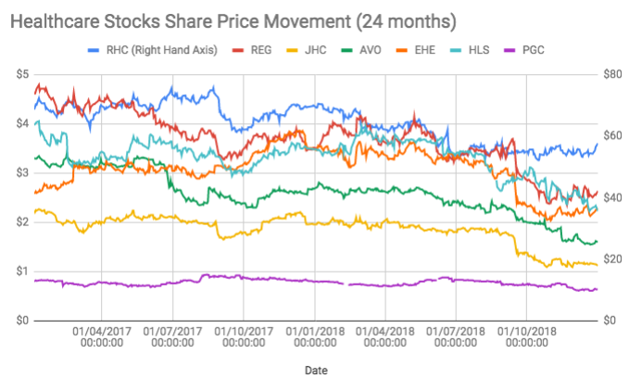

In the following chart I have indexed the companies to better show the comparative movements of each of the stocks against each other. From this perspective it is quite obvious that all the health stocks have been saddled with some negative sentiment that has kicked up a gear since the announcement of the royal commission.

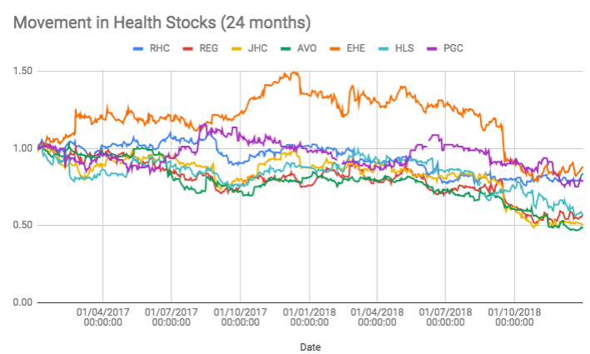

If Paragon has been caught up in the general sentiment impacting on health stocks then there exists a potential opportunity to “be greedy when others are fearful” (Warren Buffett classic!).

However, if the Royal Commission is likely to impact on the costs of the health care providers (for example requiring a minimum staffing level) then these same health care providers may have less to spend on health care products.

