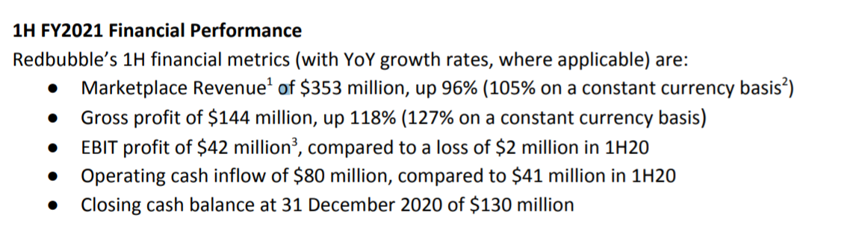

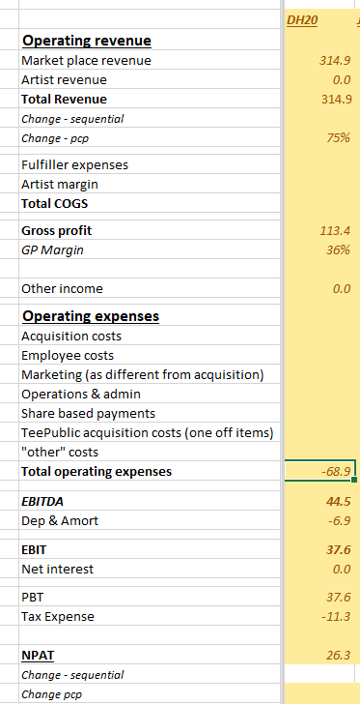

- Overstates my expectations in all categories (see above)
- Margin weaker than maybe market expected – though this was explicitly said in the last report @ JH20
- Shares hammered 15% on the day.

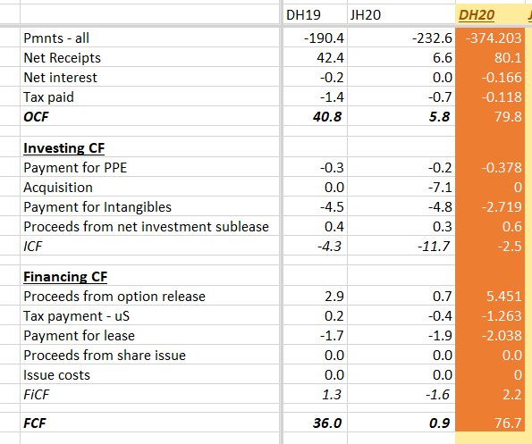

- ~75m FCF, massive improvement.

Overall
- Belted the expectations I had saved in my model
- Not sure what the market wanted – but I believe there was an ‘oversell’ today
- The new CEO is due to purchase 2m shares on market post this result, (see my thread on the new CEO announcement)
  - Theoretically he was incentivised to adhere to some costings as he can effectively buy the 2m shares (HE IS OBLIGED TO BUY) at a cheaper price/discount……
  - Nothing explicit here but worth noting
  - Unless the shares rocket tomorrow, I will be buying in the morning.

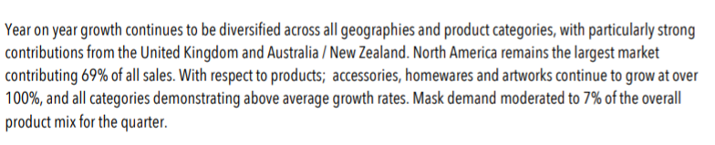

- Fiscal spending to support some consumer demand
- Good to see mask revenue falling as a % of revenue. In 3 years time I expect this to phase out to close to 0%. (given obvious covid situation)

- Given that the currency needed converting back from the US into AUD, really incredible results
- Given the inflated value of the AUD/USD, future earnings.revenues etc will be given a headwind.
- Inputs costs obviously a lot cheaper, I struggle to understand the headwind.

